. Agile Methods – Overview
What are Agile Methods?
Agile Methods are a group of software development approaches based on iterative development, where requirements and solutions evolve through collaboration between cross-functional teams. The focus is on flexibility, customer collaboration, continuous delivery, and responding to change.

⚡ Key Principles of Agile (from Agile Manifesto):
- Individuals and interactions over processes and tools
- Working software over comprehensive documentation
- Customer collaboration over contract negotiation
- Responding to change over following a fixed plan

🛠️ Popular Agile Methods / Frameworks:
- ✅ Scrum
  - Roles: Product Owner, Scrum Master, Development Team
  - Artifacts: Product Backlog, Sprint Backlog, Increment
  - Time-boxed iterations called Sprints (usually 2–4 weeks)
  - Daily stand-up meetings
- ✅ Kanban
  - Visual workflow management using a Kanban board
  - Continuous flow of tasks
  - Limits work in progress (WIP) to improve efficiency
- ✅ Extreme Programming (XP)
  - Practices: Pair programming, Test-driven development (TDD), Continuous integration
  - Focused on technical excellence and customer satisfaction
- ✅ Lean Software Development
  - Focus on eliminating waste
  - Deliver fast and improve continuously

🚀 Benefits of Agile Methods:
- Faster delivery of functional software
- Improved customer satisfaction through regular feedback
- High adaptability to changing requirements
- Enhanced team collaboration and motivation
- Early detection of defects

⚠️ Challenges of Agile:
- Requires strong collaboration and communication
- Harder to estimate time and cost upfront
- Less suited for projects with fixed, rigid requirements
- Needs experienced teams and dedicated customer involvement

Core Principles (Agile Manifesto):
- Individuals and interactions over processes and tools.
- Working software over comprehensive documentation.
- Customer collaboration over contract negotiation.
- Responding to change over following a plan.
Key Characteristics:
- Iterative development.
- Short cycles (sprints).
- Close customer involvement.
- Continuous testing & integration.
- Self-organizing teams.
Popular Agile Frameworks:
- Scrum
- Kanban
- Extreme Programming (XP)
- Dynamic System Development Method (DSDM)
- Crystal, FDD, Lean

Methodology:

1 .Extreme Programming (XP)
Definition:
XP is an Agile methodology that emphasizes technical excellence, continuous feedback, and frequent releases to improve software quality and responsiveness to changing customer requirements.
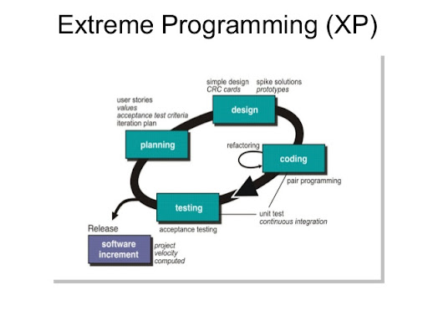

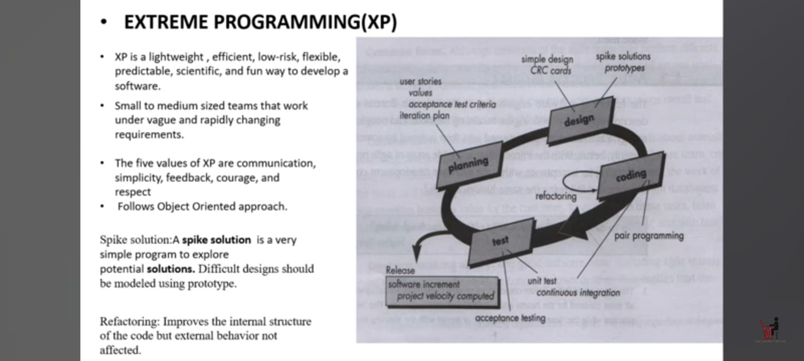

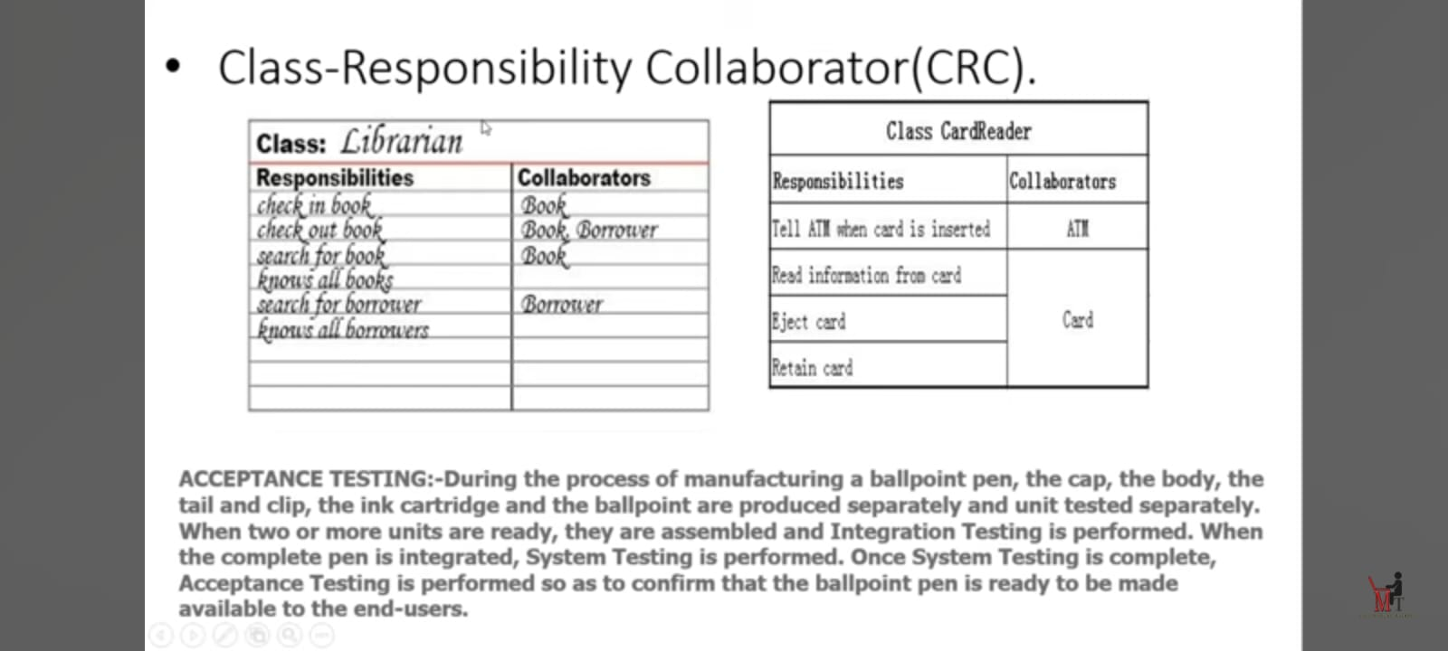
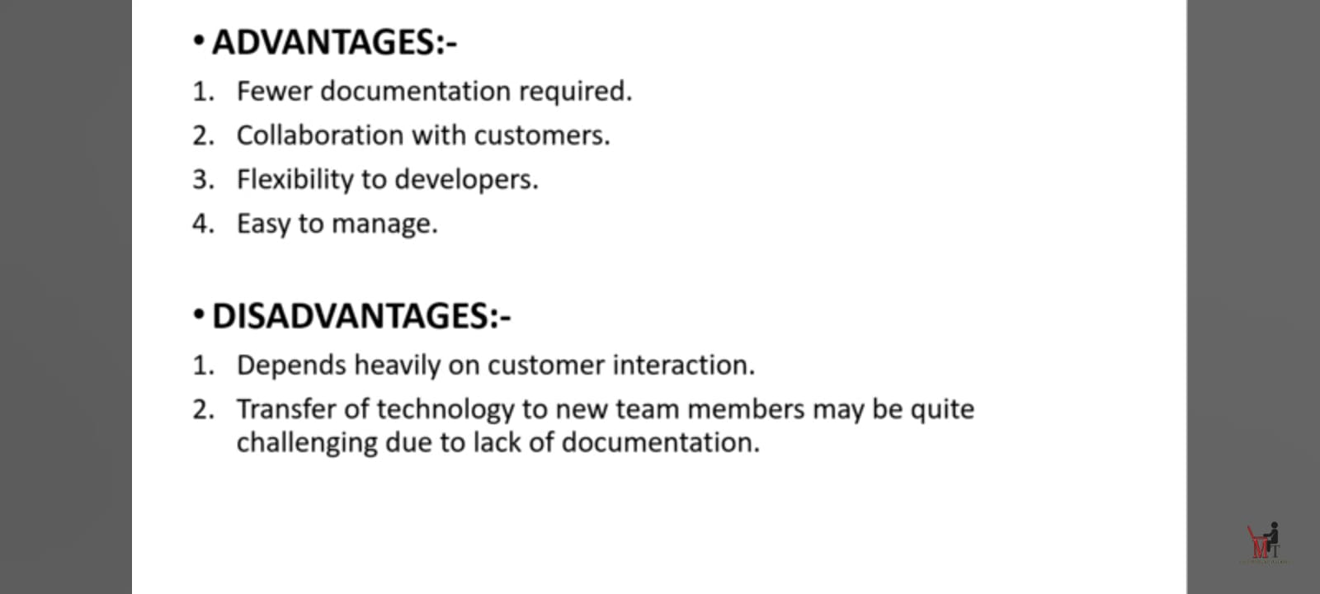
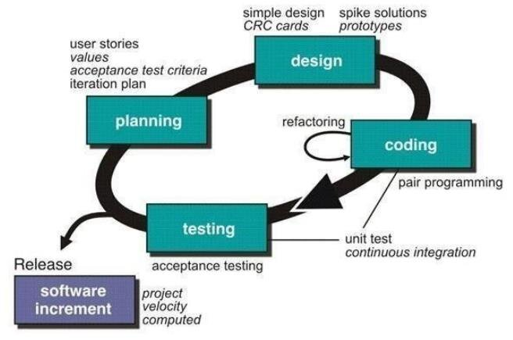
Core Practices in XP:
- Pair Programming – Two developers work together at one workstation.
- Test-Driven Development (TDD) – Write tests before writing code.
- Continuous Integration – Integrate and test code frequently.
- Refactoring – Continuously improve code structure.
- Small Releases – Deliver frequently.
- Simple Design – Build only what is needed now.
- On-site Customer – Customer representative is part of the team.
- Sustainable Pace – Avoid overwork to maintain quality.
Values of XP:
- Communication.
- Simplicity.
- Feedback.
- Courage.
- Respect.
Advantages:
- High code quality.
- Quick adaptation to changes.
- Strong customer involvement.
Limitations:
- Needs skilled and disciplined team.
- High customer commitment required.
- Not ideal for very large, distributed teams.

